1. Lakukan Pemberian IP Address, Subnet, dan Gateway pada Topologi dibawah

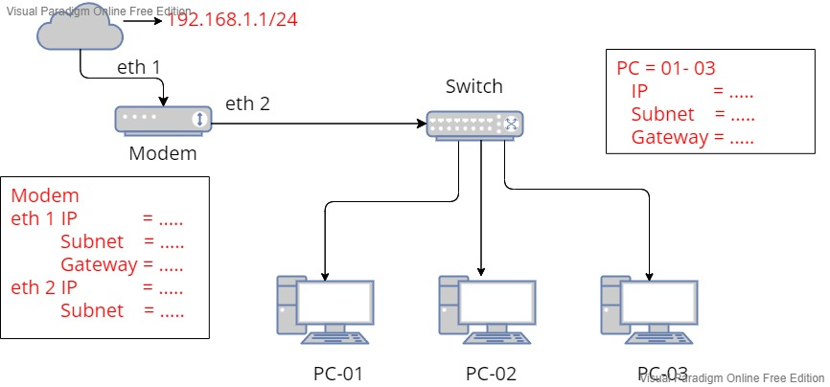

**192.168.1.2/24**

**192.168.20.3/24**

**192.168.20.1/24**

**192.168.20.4/24**

**192.168.20.2/24**

Modem : PC :

GW : 20.1 /24

IP :192.168.20.2 /24

IP :192.168.20.3 /24

IP :192.168.20.4/24

eth 1 IP = 192.168.1.2 /24

Subnet = 255.255.255.0

Gateway = 192.168.1.1 /24

eth 2 IP = 192.168.20.1 /24

Subnet :255.255.255.0

Subnet :255.255.255.0

Subnet :255.255.255.0

Subnet = 255.255.255.0

1. Lakukan Pemberian IP Address, Subnet, dan Gateway pada Topologi dibawah

eth 1 IP : 192.168.100.2 /24

Subnet : 255.255.255.0

eth 2 IP : 192.168.200.1 /24

Subnet : 255.255.255.0

eth 3 IP : 192.168.300.1 /24

Subnet : 255.255.255.0

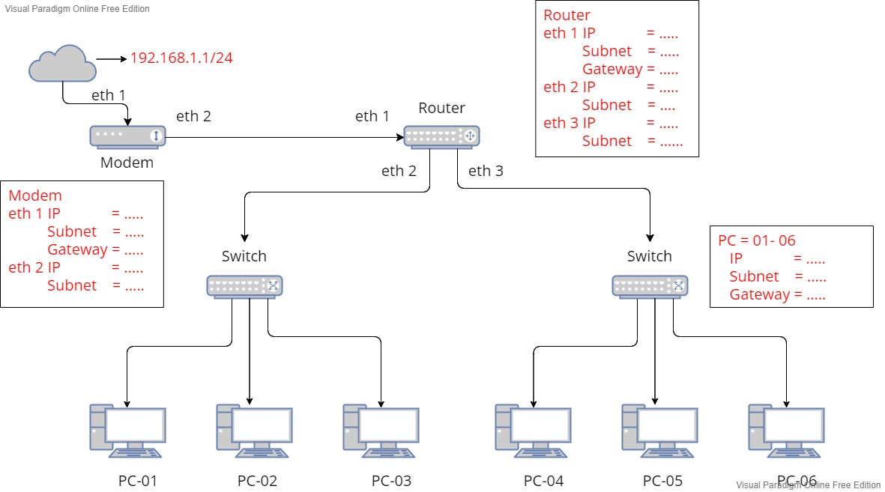

300.4 /24

300.3 /24

300.2 /24

200.4 /24

200.3 /24

192.168.100.1 /24

192.168.100.2/24 /24

192.168.300.1 /24

192.168.200.1 /24

192.168.1.2 /24

eth 1 IP : 192.168.1.2 /24

Subnet : 255.255.255.0

eth 2 IP : 192.168.100.1 /24

Subnet : 255.255.255.0

200.2 /24

IP 4 - 6 : 300.2, 300.3, 300.4 /24

Subnet : 255.255.255.0

GW : 300.1

IP 1 - 3 : 200.2, 200.3, 200.4 /24

Subnet : 255.255.255.0

GW : 200.1

1. Lakukan Pemberian IP Address, Subnet, dan Gateway pada Topologi dibawah

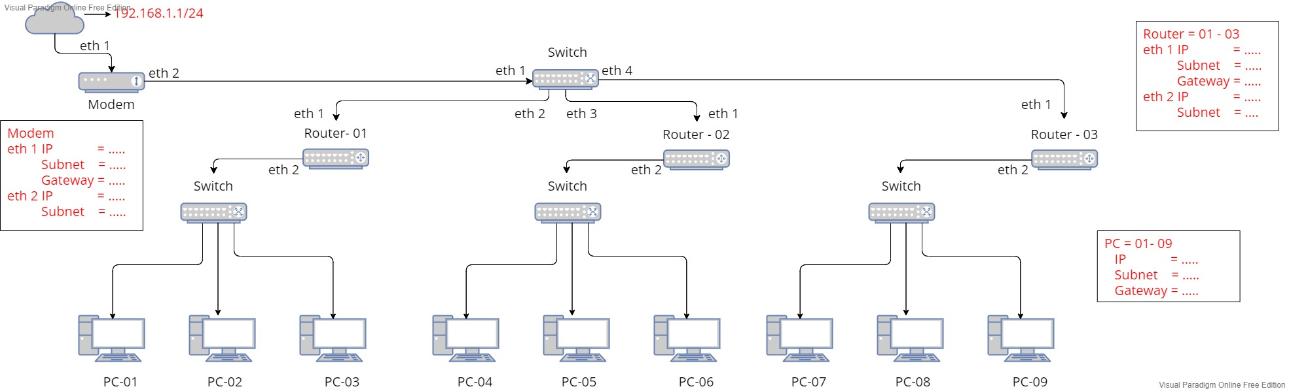

192.168.400.4 /24

192.168.400.3 /24

192.168.400.2 /24

192.168.300.4 /24

192.168.300.3 /24

192.168.300.2 /24

192.168.200.3 /24

192.168.200.4 /24

192.168.200.2 /24

192.168.400.1 /24

192.168.300.1 /24

192.168.200.1/24

192.168.100.4 /24

192.168.100.3 /24

192.168.100.2 /24

192.168.100.1 /24

192.168.1.2 /24

ROUTER 3

eth 1 IP : 192.168.100.4 /24

Subnet : 255.255.255.0

Gateway : 192168.100.1

eth 2 IP : 192.168.400.1 /24

Subnet : 255.255.255.0

ROUTER 2

eth 1 IP : 192.168.100.3 /24

Subnet : 255.255.255.0

Gateway : 192168.100.1/24

eth 2 IP : 192.168.300.1 /24

Subnet : 255.255.255.0

ROUTER 1

eth 1 IP : 192.168.100.2 /24

Subnet : 255.255.255.0

Gateway : 192.168.100.1/24

eth 2 IP : 192.168.200.1 /24

Subnet : 255.255.255.0

MODEM

eth 1 IP : 192.168.1.2 /24

Subnet : 255.255.255.0

Gateway : 192.168.1.1/24

eth 2 IP : 192.168.100.1 /24

Subnet : 255.255.255.0

PC 09

IP : 192.168.400.4 /24

Subnet : 255.255.255.0

Gateway : 192.168.400.1

PC 08

IP : 192.168.400.3 /24

Subnet : 255.255.255.0

Gateway : 192.168.13.1

PC 07

IP : 192.168.400.2 /24

Subnet : 255.255.255.0

Gateway : 192.168.400.1

PC 06

IP : 192.168.300.4 /24

Subnet : 255.255.255.0

Gateway : 192.168.300.1

PC 05

IP : 192.168.300.3 /24

Subnet : 255.255.255.0

Gateway : 192.168.300.1

PC 04

IP : 192.168.300.2 /24

Subnet : 255.255.255.0

Gateway : 192.168.300.1

PC 03

IP : 192.168.200.4 /24

Subnet : 255.255.255.0

Gateway : 192.168.200.1

PC 02

IP : 192.168.200.3 /24

Subnet : 255.255.255.0

Gateway : 192.168.200.1

PC 01

IP : 192.168.200.2 /24

Subnet : 255.255.255.0

Gateway : 192.168.200.1

**TUGAS VIDEO :** [**https://youtu.be/mYi61t4N5KE**](https://youtu.be/mYi61t4N5KE)